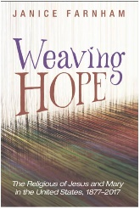**WEAVING HOPE**

**ORDER FORM**

Please complete the form and return to the address below.

Orders placed by **December 21st** will receive a 65% discount from the retail price of $42.00

(see payment summary).

**Name** *(please print)*

First Name

Last Name

**Shipping Address**

*(please print)*

Street Address



City



Province / State Postal / Zip Code



E-mail

***Payment Summary***

**Number of books ordering:**

**Orders placed BY December 21st $14.70/book $ 65% discount**

add $4.00 S&H **$**

$5.00 S&H - 2 or more

**Amount Due: $**

Make the check payable to:***Religious of Jesus and Mary***

Mail the completed form and check to: *Religious of Jesus and Mary - Provincial Office*

*ATTN: Margaret Nassar*

*821 Varnum Street, NE*

*Washington, DC 20017*

For any questions, contact Margaret Nassar at [mnassar@rjmusa.org](mailto:mnassar@rjmusa.org) or call 202-526-3203